AI BlogNest - Generate high-quality blog content using AI.

Description
AI BlogNest is a backend application created to support modern blog management with the help of artificial intelligence. It provides a REST API through which users can create, update, view, and manage blog content in an organized way. The system is developed using Node.js and Express.js, while MongoDB is used to store application data. Mongoose helps connect the application with the database and maintain the structure of stored information.
The application includes AI-based services that help users prepare blog posts, generate useful content ideas, summarize articles, and receive smart suggestions. These features reduce the time required for writing and make the content creation process easier. The backend is designed so that the frontend can communicate with the services through clear API endpoints.
Security and user access are important parts of BlogNest. JWT is used for authentication, while different roles such as Admin, Editor, Author, and Reader control what each user is allowed to do. Passwords are protected using hashing, and validation is applied to incoming data. The system also supports blog categories, tags, comments, media information, searching, and error handling.
Overall, AI BlogNest combines a normal blogging system with AI-supported services. Its modular structure makes the application easier to develop, test, maintain, and extend in the future. By bringing content management and intelligent writing assistance into one backend, the project provides a simple and useful platform for blog creators.

Scenario-Based Case Study

Background
Priya is a student and part-time content creator who maintains a personal technology blog. She writes articles about programming, college projects, and new applications. As the number of posts increases, she needs a single system to organize articles, manage readers’ comments, and use AI assistance while preparing new content.

Problem
- Difficulty managing multiple drafts, categories, and tags.
- Limited visibility into post performance and engagement analytics.
- Time-consuming processes for content approval and comment moderation.
No streamlined system for handling media uploads or metadata.
- Lack of collaborative permission tiers for editors, authors, and administrators.

Solution
The BlogNest backend provides a centralized API that connects the frontend application with the database and AI services. It separates business logic into different modules for users, blogs, comments, categories, and AI operations. Authentication and role permissions ensure that each user can access only the functions allowed for their account.

Usage
- Authors can create and edit their own blog posts, upload related media information, arrange posts using categories and tags, and check the response received from readers.
- Editors and administrators can review submitted posts, update publishing status, manage comments, maintain categories, and control user permissions through protected API routes.
- Readers can view available blog posts, search for useful articles, and add comments after authentication.

Outcome
After implementing the backend, blog-related activities become easier to manage from one place. The database structure remains organized through schema validation, user access is controlled through authentication, and the stored information can be used to understand blog activity and improve future content.

1. Software Requirements
- Operating System: Windows 10/11, macOS, or Linux (supports cross-platform operations).
- Node.js (v16 or above): Runtime ecosystem running server logic and routing infrastructure.
- npm (v8 or above): Node package manager to control operational dependencies.
- Express.js: Lightweight routing web framework to construct backend RESTful entry points.
- MongoDB: Document NoSQL engine storing users, posts, categories, comments, and analytics metrics.
- Postman: API verification toolkit to assert schema validation responses across administrative route shields.
- Code Editor: Visual Studio Code or similar IDE environment.

2. Hardware Requirements
- Processor: Intel Core i5 (8th Gen or above) / AMD Ryzen 5 or equivalent.
- RAM: 8 GB minimum (16 GB recommended for concurrent instances of MongoDB, processing layers, and execution nodes).
- Storage: 1 GB of available disk workspace.

Epic:-1 PROJECT ARCHITECTURE
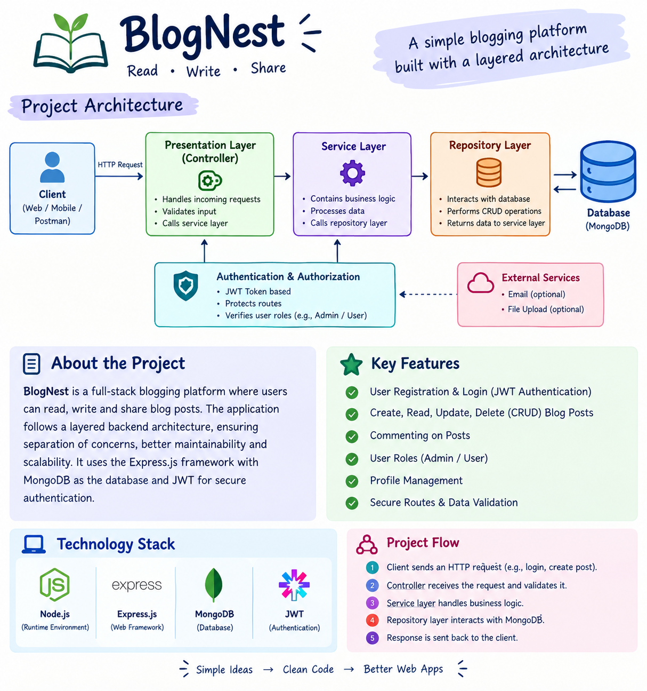

The BlogNest project follows a layered backend architecture in which each part performs a separate responsibility. A request first reaches the API interface, passes through security and validation checks, and then moves to the required service and database layer. This separation helps the application remain organized and makes debugging and future changes easier.
The BlogNest application exposes structured endpoints handled by a layered server architecture model. Incoming requests undergo filter processing before interacting with data services.
Interface: Postman or another API client is used to send requests and view JSON responses from the available endpoints.
- Express Server Gateway: Receives client requests, identifies the HTTP method, reads JSON data, manages routes, and sends the appropriate response.
- Authentication & Role Matrix Middleware: Checks the JWT token, identifies the logged-in user, and verifies whether the user’s role has permission to access a protected route.
- Granular Services (Logic Modules): Contains separate functions for blog creation, editing, publishing, comment handling, category management, and report-related operations.
- Database Interface Layer: Mongoose connects the backend with MongoDB and helps the application create, read, update, and delete stored documents.
AI Flow (Service Integration): Connects the backend with AI services for tasks such as generating blog drafts, improving content ideas, and creating short summaries from longer articles.
- BlogGenerator with AI: Uses the AI service to prepare an initial blog draft from a topic or prompt, allowing the author to review and edit the content before publishing.
- BlogGenerator with AI: A specialized service that automates the generation of blog content, which integrates with the AI Flow service to streamline the drafting process.

Entity-Relationship (ER) Diagram Description
The underlying document structure manages several collections bound by logical application referenc
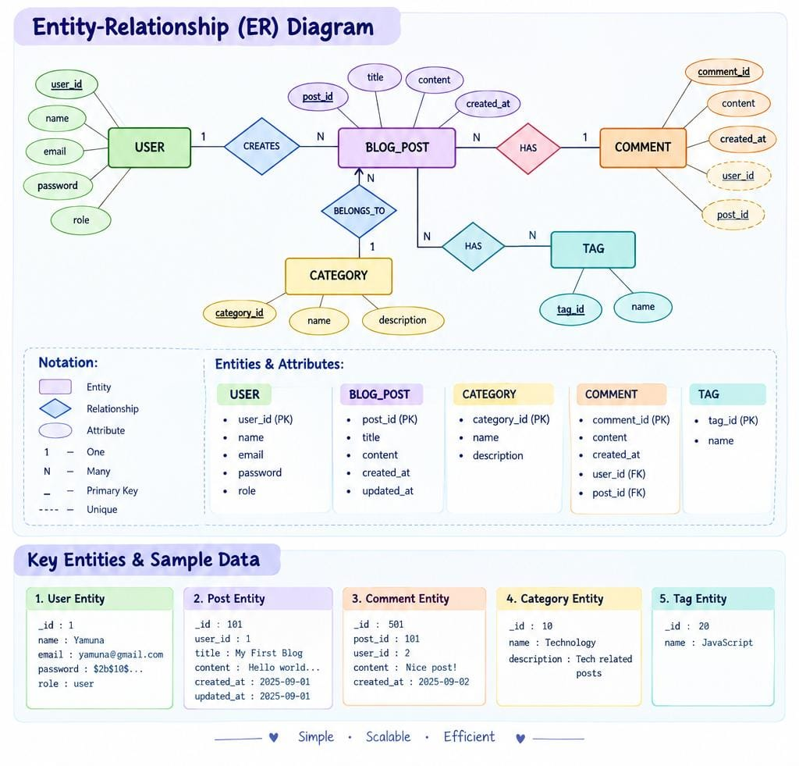

1. User Entity
- _id (Primary Key - ObjectId)
- name (String, Required)
- email (String, Required, Unique)

password (String, Hashed, Required)
- role (String, Default: "reader")

2. Post Entity
- _id (Primary Key - ObjectId)
- userID (Foreign Key referencing User Collection)
- name (String, Required - represents Title)
- photo (Object/String pathway link)
- message (String - Core content body)
- likes (Number, Default: 0)
- timestamps (True)

Key Structural Mappings
- User to Post (One-to-Many): An author can submit multiple blog documents.
- User to Comment (One-to-Many): Readers/Users can append multiple response comments across independent post nodes.
- Post to Comment (One-to-Many): A single blog document stores individual referenced comment submissions.

Key Features
- Role-Based Route Guarding: Strict token processing blocks unauthorized tiers from modifying core settings.
- CRUD Blog Execution Engine: Complete schema management over content definitions, status states, and asset assignment paths.
- Categorization System: Native tag indices facilitate filtering and querying for enhanced discoverability.
- Comment Moderation Logic: Protected entry points for updating moderation flags
(approved, pending, spam).
- Sanitization Safeguards: Payload parameter sanitation prevents XSS vectors and NoSQL parameter manipulation injections.
- I-Driven Blog Generation Pipeline: Integrates external Large Language Model (LLM) abstractions and context-aware prompt templates to synthesize full-length, structured blog posts from high-level thematic inputs.
- Intelligent Content Summarization Engine: Leverages semantic compression layers to parse extensive article payloads, dynamically generating concise abstracts and automated metadata summaries.

Roles and Responsibilities
Admin: Complete environment override control. Can manage user database registrations, alter role assignments, prune malicious comments, and inspect full logging entries.
- Editor: Focuses on editorial workflows. Reviews pending draft posts, marks records for instant publication, and handles category cleanup scripts.
- Author: Restricted account access. Can issue creation statements only for posts bound to their explicit account record.
- The MVC architecture divides the application into three main parts: Model, View, and Controller. Each part has a separate role, so database operations, request processing, and API communication can be managed independently. This makes the backend easier to understand, test, and maintain.
User Flow:

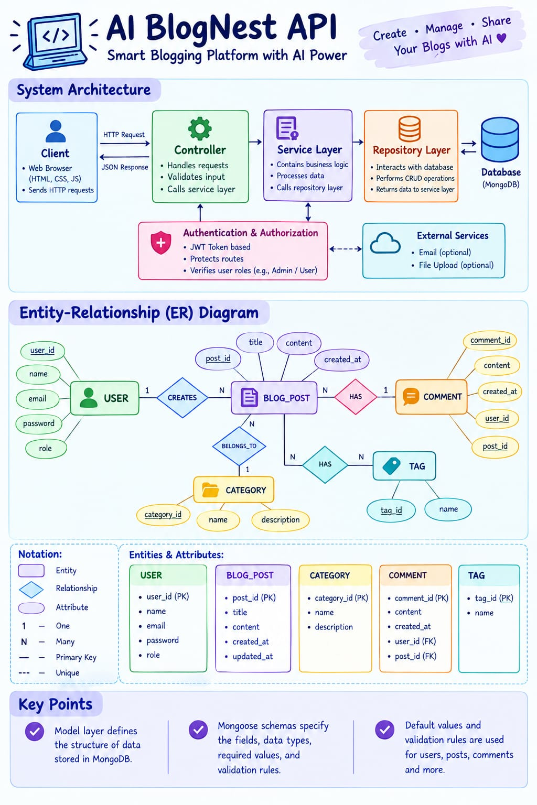
The Model layer defines the structure of data stored in MongoDB.
Mongoose schemas specify the fields, data types, required values, default values, and validation rules for users, posts, comments, and other collections.
The system architecture structures its source configuration layers around the Model-View-Controller design pattern to completely decouple components:
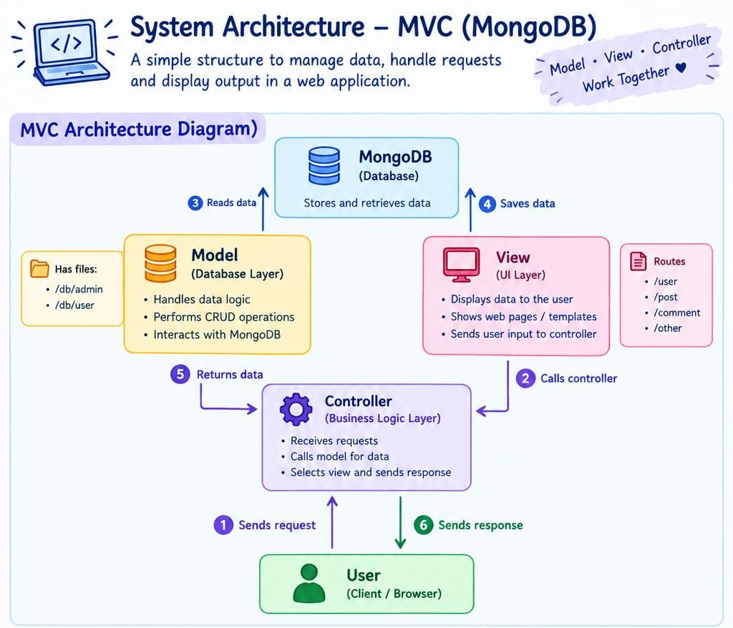
The Controller layer receives requests from the routes and controls the main application process. It checks the input, calls the required model or service, handles the result, and sends a suitable JSON response back to the client.
Defines structure blueprints via strongly enforced Mongoose schemas mapping explicit fields into raw collection items inside MongoDB. It sets default states, indexing rules, and transformation parameters before validation persistence occurs.
The View layer represents the response interface used by the client. Since BlogNest is a headless backend, it does not contain traditional webpage templates. Instead, API responses in JSON act as the output that can be displayed by a frontend application or tested using Postman.
The intermediary brain of the ecosystem. It captures request vectors from the execution routes, checks structural request constraints, delegates processing workflows directly to models, and packages the resultant output into standard JSON return arrays.

View Layer (Routing Network Interface

Epic2: Project Setup and Configuration

Creating project folder
Create a new folder with your <project name>.
Inside that folder create one new folders.
- Name another one as Server.
- Now open that folder in VS

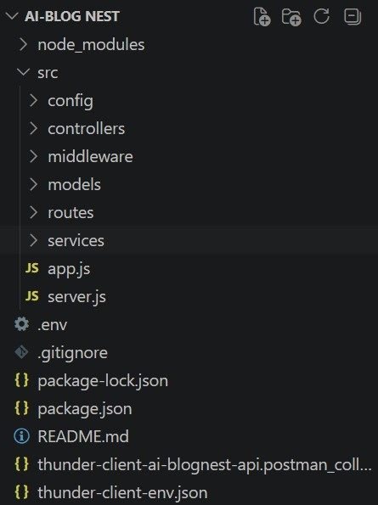

Server setup (npm init)

○ Open Server folder in terminal of VScode.
■ npm init -y ○ Create files:
■ server.js ○ Create folders:
■ models
■ controllers
■ routes

Epic 3: Backend Development
Server.js
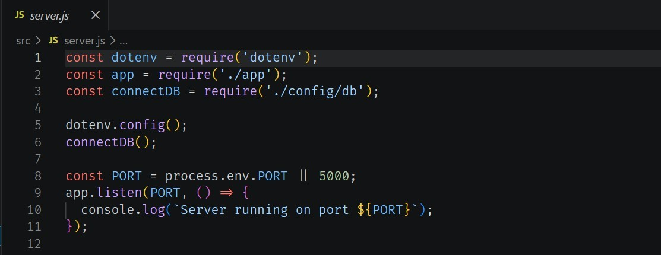

App.js
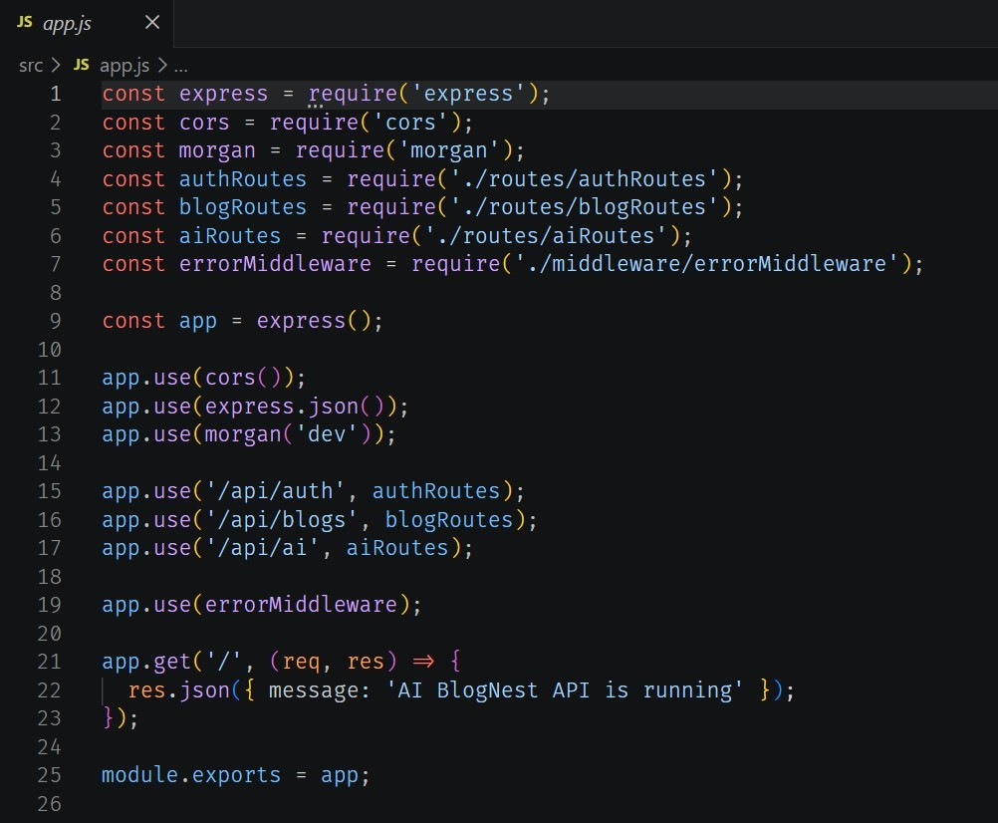

Epic4: Database Configuration
DB Connection:-
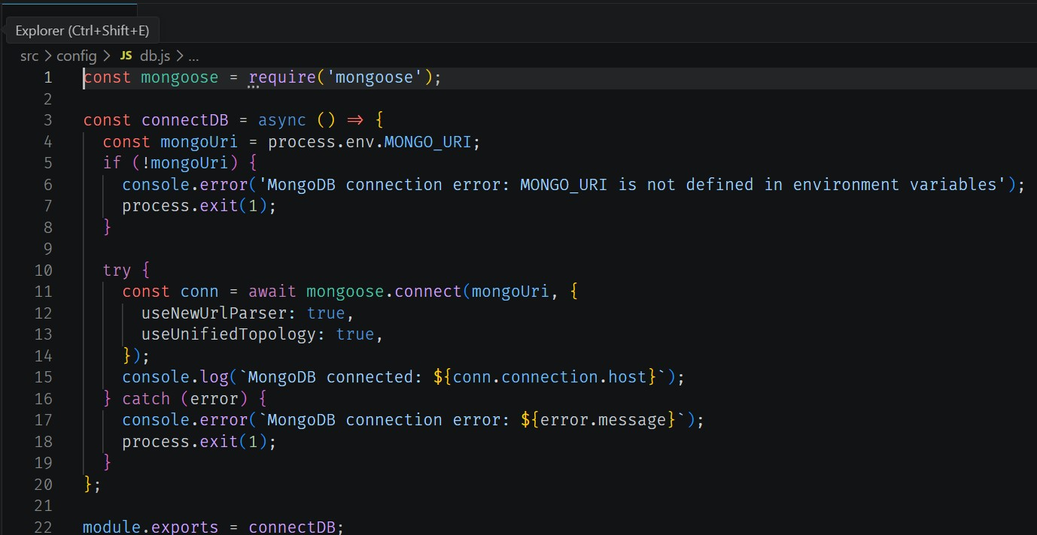

1. Configure MongoDB:
● Install Mongoose.
In your Node.js project directory, run:
npm install mongoose ● Create database connection. ● Create Schemas & Models.
Create Database connection:
Now, make sure the database is connected before performing any of the actions through the backend. The connection code looks similar to the one provided below

Mongoose Schema Definitions

1. Identity Resource Document Schema (schemas/userModel.js)
Enforces field criteria validations on incoming database creations:
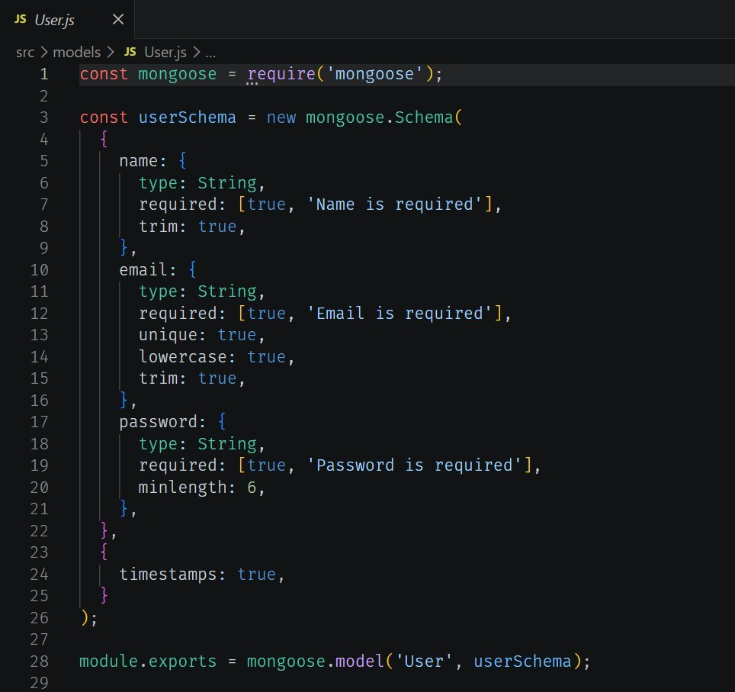
Epic 5: Project Executions:
· Install Postman or ThunderClient (VS Code extension).
· Start the backend server:

“npm start”
API Testing
User Registration :
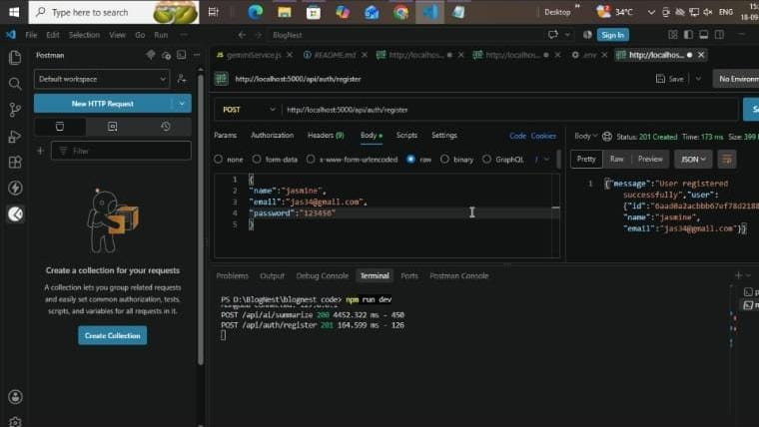

User Login:
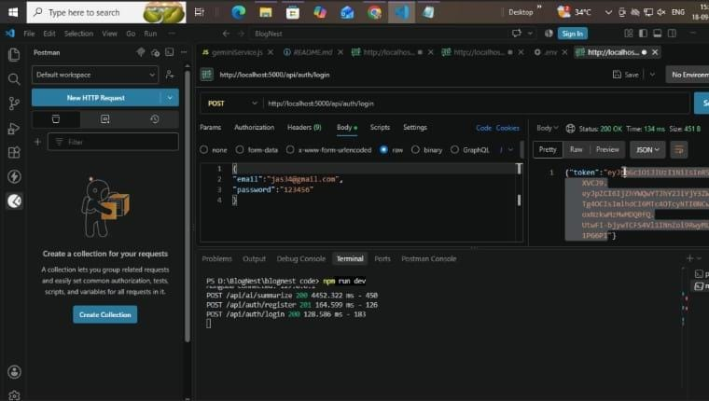

Create Blogs :
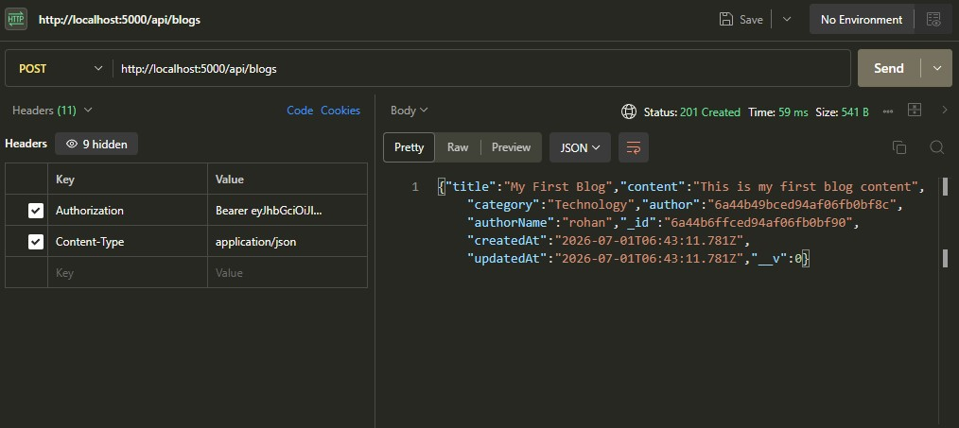

Fetch Blogs :
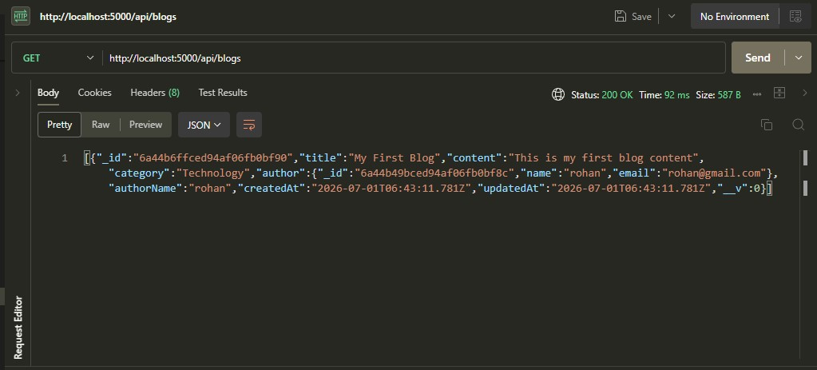
Generate AI blogs :
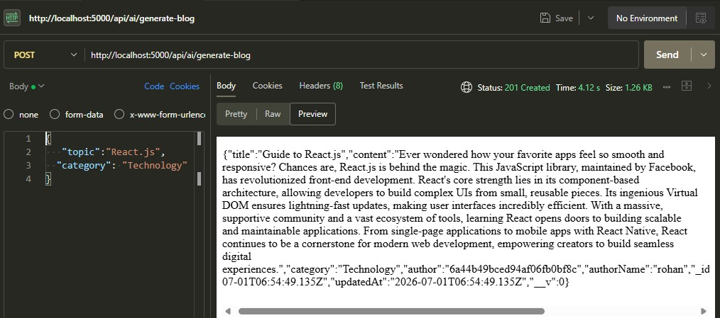
Summarize Blogs :
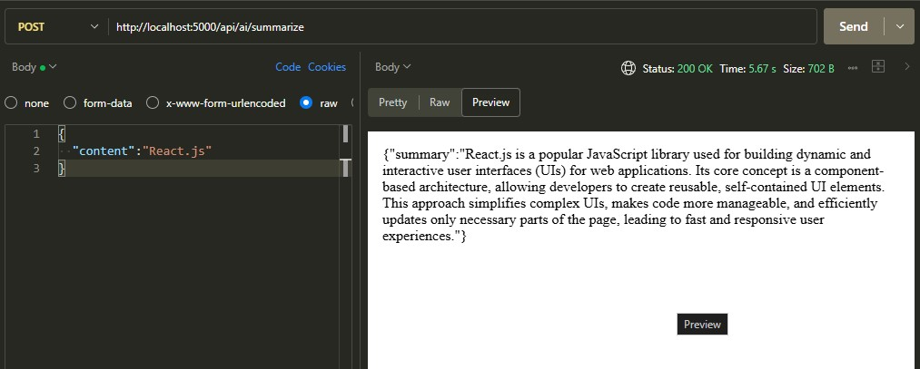
Demo Video: https://drive.google.com/file/d/1-wr1Lnqzo54bc82SBPrIc62d1WDB_XAj/view?usp=drivesdk
CodeDrive: https://drive.google.com/file/d/1hSwOOTYM4BKWsCUC0i_bxDXYr981WGciR/view?usp=sharing

